IN THE CIRCUIT COURT OF CASS COUNTY, MISSOURI
APRIL SANDS,  Plaintiff,  v.  COMPASS HEALTH, INC., et al.,  Defendants. | )  )  )  )  )  )  )  ))  )  ) | Case No. 24CA-CC00145  Division 2
DEPOSITION OUTLINE - Kelly Phillips
Overview:
Kelly Phillips is a therapist/client access specialist at Compass. Kelly Phillips was Jenny Carter’s supervisor.

Main depo points:
- Triage / admission process
- Compass’s safety violations / unsafe conditions
- Setting Jenny Carter up as a comparator

PREFATORY QUESTIONS
Do you understand that you have been placed under oath?

What does this oath mean to you? (he will likely say “I have to be honest”)

It is always important to be honest, but most conversations in our society occur without an oath, don’t they?

Our judicial system depends heavily on absolute honesty by every witness, and the system breaks down if witnesses shade or distort the truth.

Do you agree to be honest today and abide by your oath?

Name (Full Legal)

Date of Birth

Employed/Position

Home Address

Business address/email address/phone #

Have you ever been arrested?

Have you ever been found guilty or pled guilty, or no contest, to any criminal charge?

Have you ever been a party to any case in court: sued someone, been sued by someone.
Basics

Verbal responses
If you don’t understand any of my questions.

But if you don’t ask for clarification, I’ll assume that you have understood the question.

If at any time you want to take a break, we can take a break, unless there’s a question pending - in that case you need to answer the question first and then we’ll get you a break.

You understand as we take breaks that you will remain under oath during the course of this deposition, right?
Are you under the influences of any substances or medications that might hinder your ability to recall facts or answer questions accurately today?

Can you think of any other reason why you might not be able to answer questions accurately today?

Is there any reason why your deposition should not go forward today?
Where are you located right now?

Anyone else in the room with you?

Do you have any other windows open on your computer?

Any documents in front of you?

Any notes / notepad?
Do you use social media, such as Facebook, Twitter, or Instagram?
If so, what names/handles do you use?

Instagram handle -
Facebook:

Have you ever complained about or commented about work or other employees on your social media?

Do you use LinkedIn?

Job History:

What is your personal email address?

If you have multiple, what are they?
Are you represented by counsel here today?

Who is your counsel?

Meet to prepare?

How long?

How many times?

Anyone else present?

What documents did you review?
Have you testified in any other cases?

Ones involving Compass?
What’s your highest level of education?

Job duties, supervisor, supervisees, etc
What is your personal phone number?

Work number - different or same?

Does Compass provide you with a phone?

Do you use it to make phone calls at work?

Text coworkers?

Tell me about all of them.

When was your last communication with:
- April Sands
- Courtney Langston

Did you use an internal messaging system at work?

Do you delete messages from these systems?

Does it keep everything - for all time?

How long does it keep things for then?

Rules of the Road

Explain discrimination to me.

Why is it wrong?

You agree that it’s illegal for an employer to discriminate.

Why is retaliation wrong?

What is Compass’s policy on sexual assault / sexual harassment?

Include harassment / assaults by patients?

What should compass do after a report of sexual assault / harassment?

What is your typical process?

Workplace violence - staff to staff - tolerated at Compass?

You agree that as a Compass employee - you have a duty not to retaliate?

What is a Compass Health Event Report?

Why have them?

What should Compass do after receiving a Health Event Report?

Typical steps?

Is employee safety important to Compass?

Why?

Patient safety?

Other Documents
Ex. 14 - Compass’s 2nd Supp. Answers to P’s ROGs
Page 1 is question, Page 2 is answer
Kelly Phillips identified as someone with discoverable info

NEW Ex. — Kelly Phillips Personnel File

Job Descriptions
- P. 19, Clinic Access Specialist, signed 4/5/23 (most recent role)
Under essential functions:
What does it mean to assess a patient presenting to open access? What is the Compass assessment process for patients? How are patients accessed? Have you ever recommended Compass reject a patient? Is there a policy / training outlining this process and the standards for evaluating a patient?

- P. 10 - Client Access Specialist, signed 1/11/23
- P. 13 - Triage Clinician Lead, signed 6/9/2022
Under essential functions:
What is the triage process at Compass? What is the difference between triaging a patient and assessing a patient presenting to open access? Is there a policy / training outlining the triage process?

- P. 22, Clinic Access Specialist, signed 4/27/22
- P. 16, Therapist, signed 11/19/2021

Performance Review (only from 2022)
- P. 110 - 6 Month Performance Review
  - Dated 5/25/22
  - “You’ve got it”

Compensation
- P. 100 - FY 23, $81,286.50
- P. 104 - FY 24, $107, 488.32
- P. 102 - FY 25, $115, 484.20

NEW Ex. — Compass 1038-1043
Jennifer Carter Reference Letters and Internal Rehire Evaluation

- P. 10 - email from Lauren Bruce to Velina Todd on 5/13/2024, Lauren says she wouldn’t consider Jenny for rehire
- P. 9
  - 5/13/24, email from Velina to Kelly asking for feedback about Jenny
  - 5/14, Kelly replies (only email w/ kelly on it)
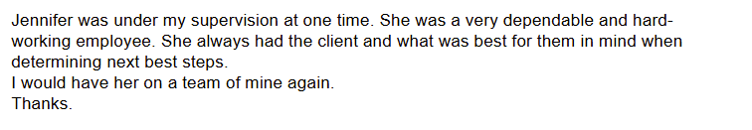
When did you supervise Jenny?

Ms. Carter did not make you or Compass aware of any disabilities?

She never filed a health event report.

She did not put you on notice of any workplace injuries.

She did not file an internal report of discrimination or retaliation?

Did Compass allow Jenny to be rehired?

Ex. 21 - Eric Kugler Statement
- Did you know Eric Kugler?
- Maybe clarify line 9 re. Staff bonuses being tied to admission numbers

Ex. 24 – Tyler Nickell Statement

Ex. 37 - Aff. of April Sands (if we want to walk through understaffing section)

Policies & Procedures

NEW EX. – Compass 787 Enrollment & Discharge Overview
Start of page –
What is the difference between “admission” and “basic assistance”?
What is the criteria for “admission” to the CAP?
How do the CAP nurse and TCL make that determination?

EX. 34 - Compass Event Reporting Policy Compass 495-500
Do you receive Compass health event reports?
Bottom of page 1-2
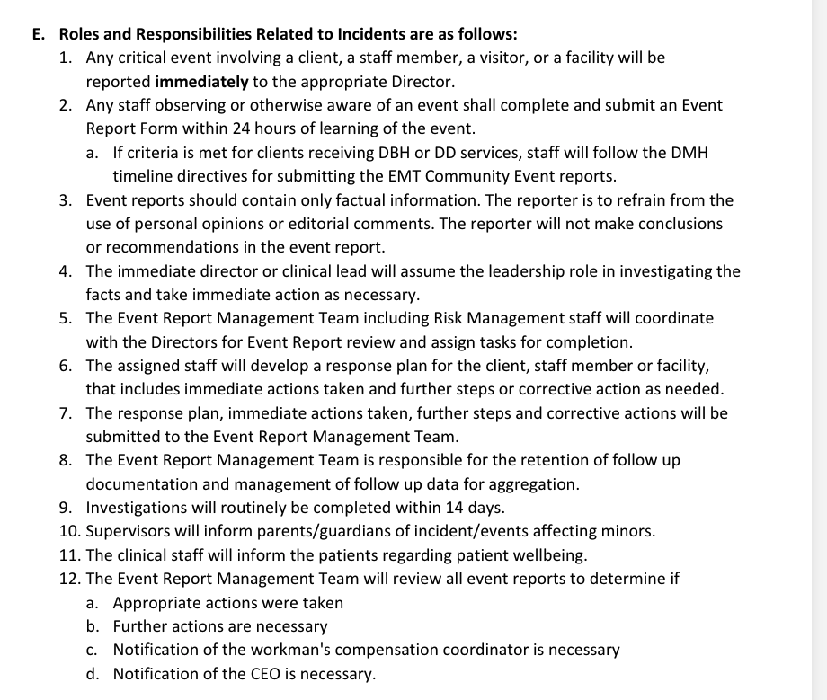

NEW Ex. — Compass 860-862 - Emergency Safety Interventions
Page 3 -
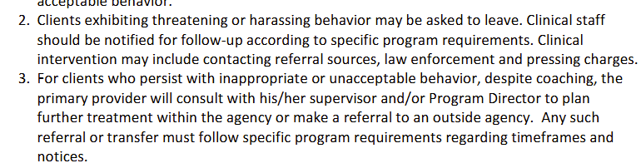
If a client exhibited threatening or harassing behavior on a past visit and comes to the facility for readmission, does Compass readmit them?
How does Compass proceed if a client exhibits sexual harassing / assaultive or violent behavior to an employee?
Who at Compass can call law enforcement? Do employees require approval from a supervisor to call law enforcement?

Breakroom Incident (only if she was Jenny’s supervisor during December 2022)

Ex. 17 - Compass 536 - 548

P. 12 -
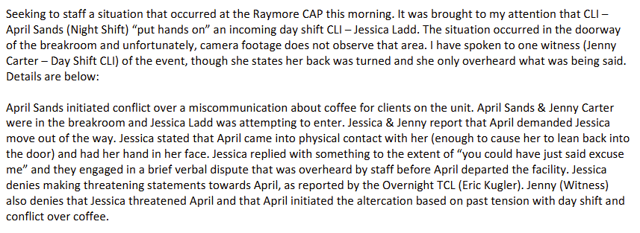
Did you discuss this incident with Jenny?
Did you review footage of the breakroom?
Have you ever put in a ticket to retain a video you reviewed?

